CS6650 Midterm Mastery
Step III: Crashing and Recovering
Cascading Failure Demo with Resilience Patterns
ECS Fargate | Terraform | Go | Circuit Breaker | Bulkhead | Fail Fast

1. Overview
This report documents a crash-and-recovery experiment built on top of the Homework 6 product search service. The goal was to demonstrate how cascading failures propagate through a distributed system when a downstream dependency degrades, and how resilience patterns from Sam Newman's Building Microservices can protect the system from total failure.
The experiment was deployed to AWS ECS Fargate using Terraform, with an Application Load Balancer routing traffic to the search service. Load testing was performed using Locust with 20 concurrent users across four distinct test phases.

2. Architecture
The system consists of two microservices deployed as separate ECS Fargate tasks:
- Product Search Service (port 8080): Generates 100,000 products at startup using sync.Map, handles search queries by checking the first 100 products, and calls the downstream recommendation service for each request. Exposed behind an Application Load Balancer.
- Recommendation Service (port 8081): Returns product recommendations. Supports runtime failure injection via a /mode endpoint to simulate slow responses (3–8 second delay), errors (80% failure rate), or progressive degradation.
The search service has two operational modes controlled by the RESILIENCE environment variable, toggled via a single Terraform variable:
- RESILIENCE=false: No protection. The service waits indefinitely for downstream responses, making it vulnerable to cascading failures.
- RESILIENCE=true: Three resilience patterns activate — Fail Fast (500ms timeout), Circuit Breaker (opens after 5 failures, retries after 15s), and Bulkhead (max 10 concurrent downstream calls). When the downstream is unavailable, the service returns fallback recommendations.

3. Deployment
The entire infrastructure was provisioned using Terraform with a single deploy-aws.sh script that builds Docker images, pushes them to Amazon ECR, and deploys to ECS Fargate.
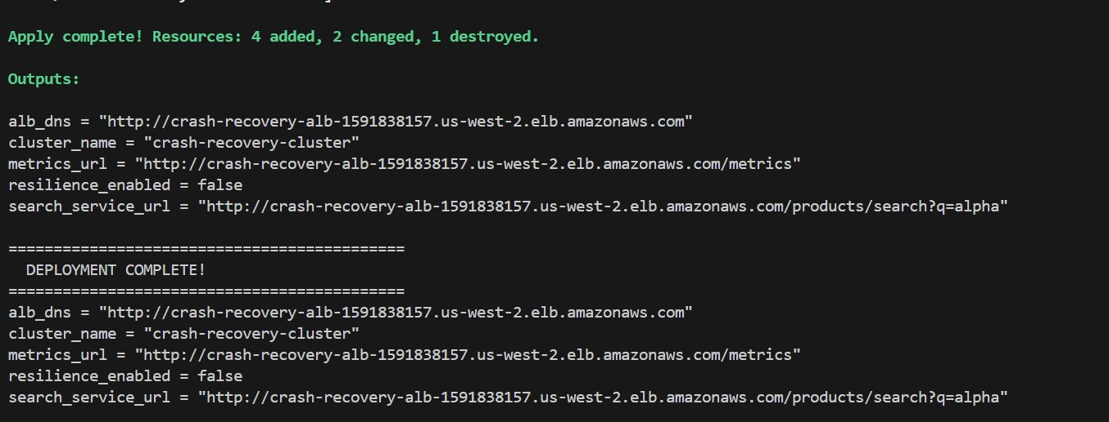
Figure 1: Terraform deployment output showing successful creation of ALB, ECS cluster, services, and Service Discovery.
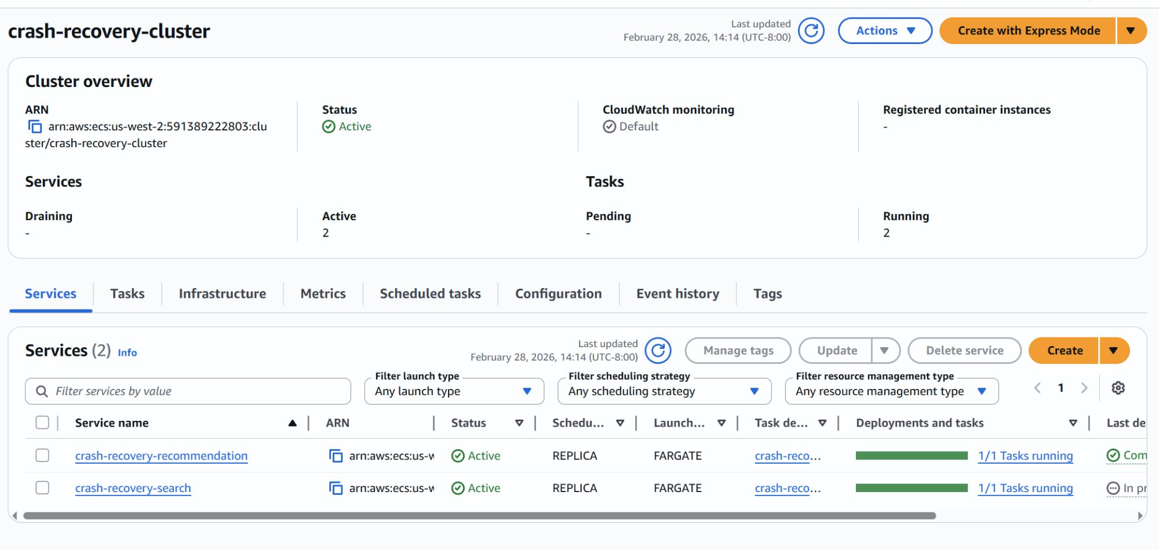
Figure 2: AWS ECS Console showing crash-recovery-cluster with both services (search and recommendation) running on Fargate.
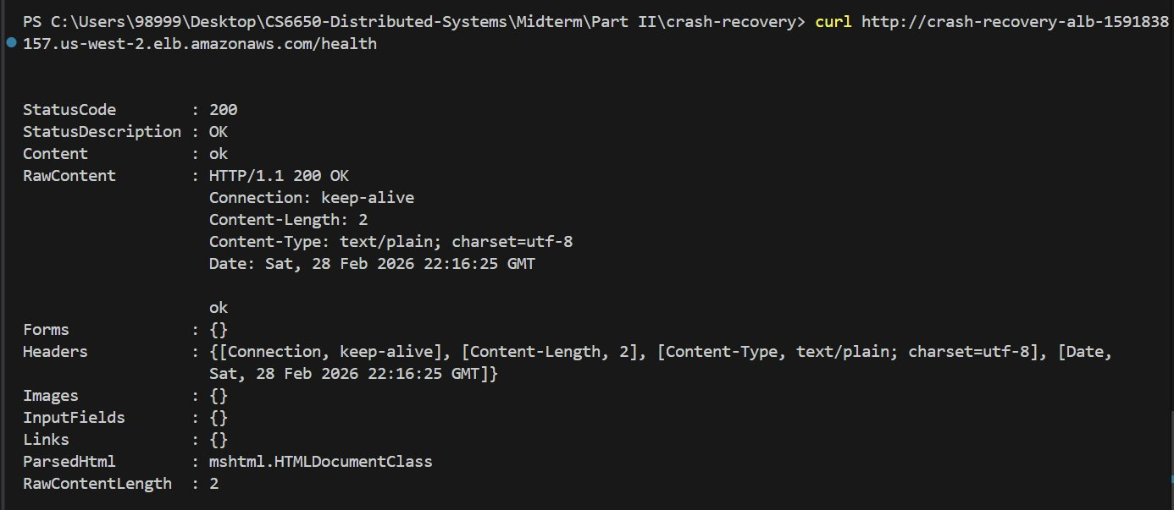
Figure 3: Health check confirming the search service is reachable through the ALB (HTTP 200, content: "ok").

4. Phase 1: The Crash (No Resilience)

4.1 Baseline Test (Healthy Downstream)
With both services running normally (RESILIENCE=false, downstream in "none" mode), a 1-minute Locust test with 20 concurrent users established the baseline performance:
Metric | Value | Notes
Requests/sec (RPS) | 89 | Aggregate across all endpoints
Avg Response Time | 16 ms | Fast: search + downstream call
Median Response Time | 15 ms | Very consistent
Max Response Time | 151 ms | Occasional tail latency
Total Requests | 6,854 | In 1 minute
Failures | 0 | 100% success rate

4.2 Triggering the Failure
The recommendation service was switched to "slow" mode via its runtime API, causing it to inject a random 3–8 second delay on every response:
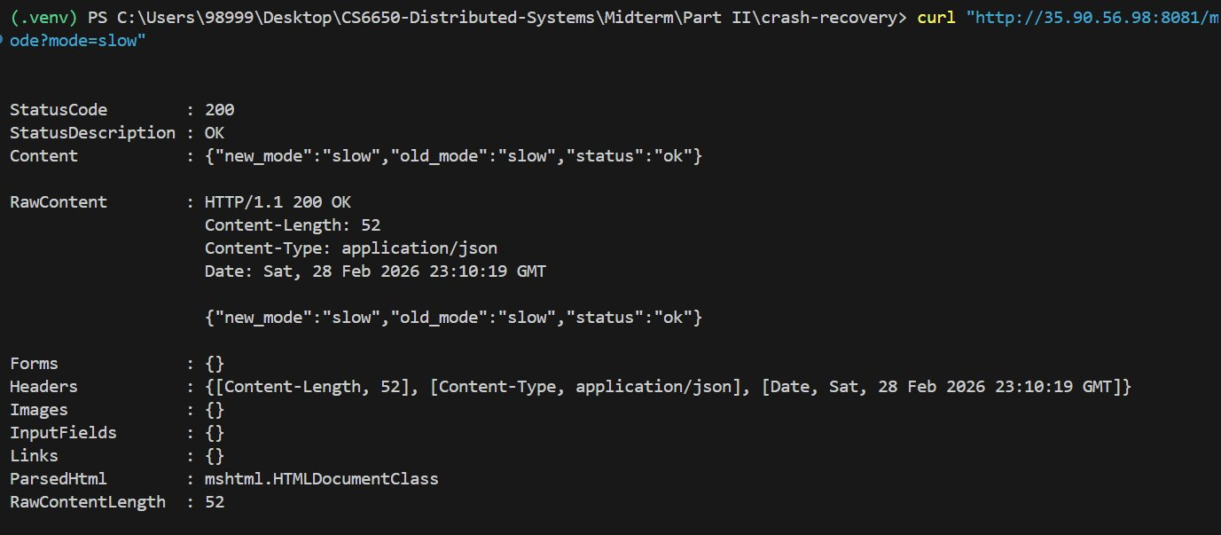
Figure 4: Triggering slow mode on the recommendation service (old_mode: "none" → new_mode: "slow").

4.3 Load Test Under Failure
With the downstream now responding in 3–8 seconds, the same 20-user Locust test was run for 2 minutes. The results were catastrophic:
Metric | Baseline | Under Failure | Change
RPS | 89 | 4 | −95%
Avg Latency | 16 ms | 4,644 ms | 290x slower
Median Latency | 15 ms | 5,200 ms | 347x slower
Max Latency | 151 ms | 8,015 ms | 53x slower
Total Requests | 6,854 | 478 | −93%

The cascading failure mechanism: every incoming request spawns a goroutine that blocks waiting for the slow downstream. With the downstream taking 3–8 seconds per response, goroutines pile up, and the system can only process approximately 4 requests per second instead of 89. Throughput dropped by 95%.

4.4 Metrics and CloudWatch
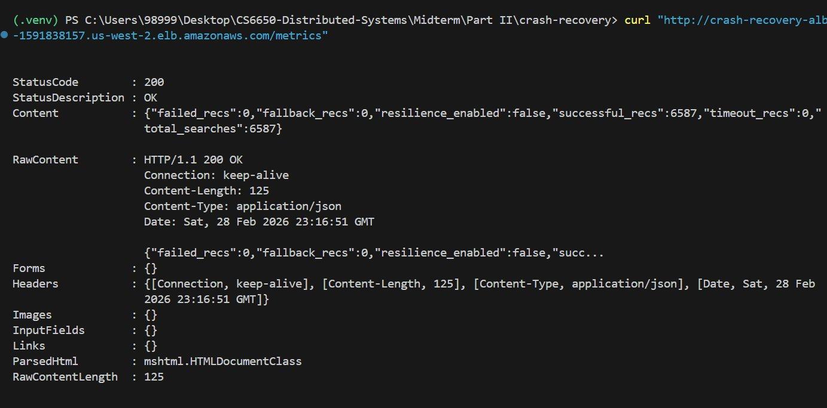
Figure 5: Service metrics with resilience_enabled: false. All 6,587 requests "succeeded" — they just took 3–8 seconds each. No fallback or timeout mechanism exists.
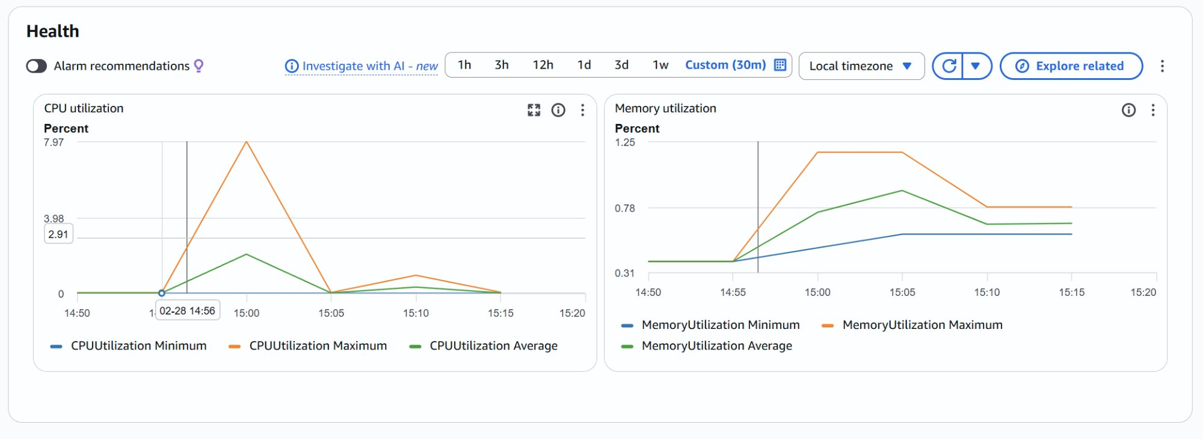
Figure 6: CloudWatch CPU and Memory. CPU stayed below 8% — the bottleneck was I/O wait (goroutines blocked on network), not computation. Memory rose as blocked goroutines accumulated.

5. Phase 2: The Fix (With Resilience)

5.1 Enabling Resilience Patterns
The fix was deployed by changing resilience_enabled from false to true in terraform.tfvars and running terraform apply. This updated the search service's RESILIENCE environment variable, triggering a new ECS task deployment:
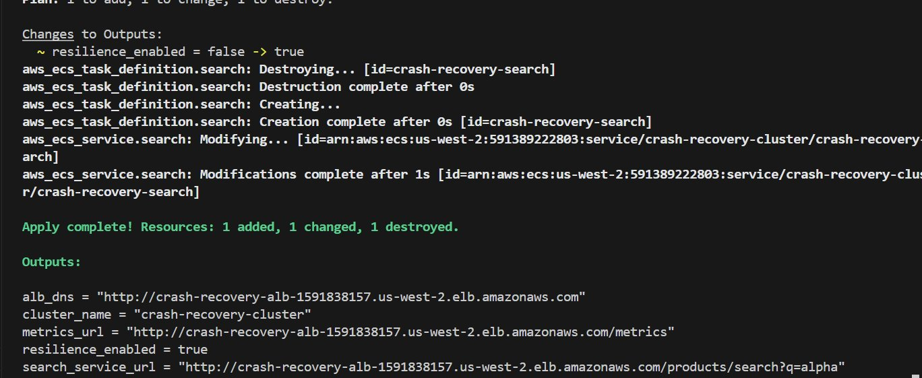
Figure 7: Terraform apply showing resilience_enabled = false → true. Task definition recreated, service updated in 1 second.

5.2 Three Resilience Patterns
Pattern 1: Fail Fast (Timeout)
The HTTP client for downstream calls uses a 500ms timeout. Instead of waiting 3–8 seconds, the service times out after half a second and returns fallback recommendations. This prevents goroutines from blocking indefinitely.
Pattern 2: Circuit Breaker
After 5 consecutive failures (timeouts), the circuit breaker opens and stops making downstream calls entirely for 15 seconds. All requests immediately receive fallback recommendations with zero network overhead. After the cooldown, it enters "half-open" state and allows test requests through. If they succeed, the circuit closes and normal operation resumes.
Pattern 3: Bulkhead
A semaphore limits concurrent downstream calls to 10. Even before the circuit breaker trips, only 10 goroutines can wait on the downstream simultaneously. Remaining requests are served with fallback recommendations immediately, isolating the failure.

5.3 Confirming Failure Conditions
Before testing, the downstream was confirmed to still be in slow mode:
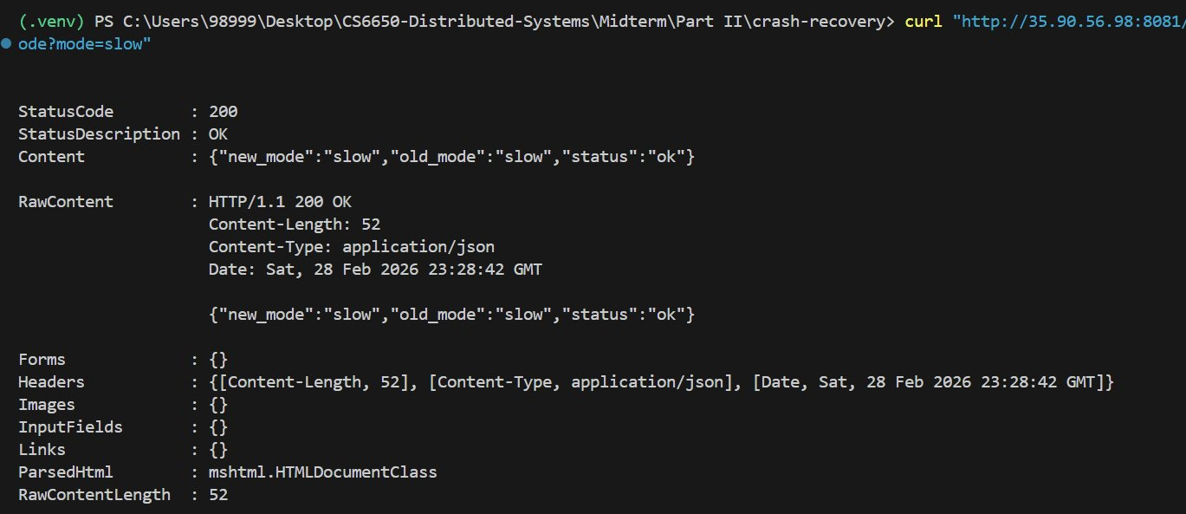
Figure 8: Confirming the recommendation service is still in slow mode (same failure conditions as Phase 1).

5.4 Load Test Results
With identical failure conditions (downstream in slow mode), the 20-user Locust test was repeated for 2 minutes:
Metric | Baseline | Crashed | Resilient | Recovery
RPS | 89 | 4 | 89 | 100%
Avg Latency | 16 ms | 4,644 ms | 18 ms | 99.6%
Median | 15 ms | 5,200 ms | 14 ms | 99.7%
Max | 151 ms | 8,015 ms | 538 ms | 93.3%
Requests | 6,854 | 478 | 10,683 | —

The resilience patterns restored throughput to baseline levels (89 RPS) with negligible latency increase (18ms vs 16ms). The max latency of 538ms represents the few requests that hit the 500ms timeout before the circuit breaker opened. Once open, all subsequent requests were served instantly with fallback data.

5.5 Resilience Metrics
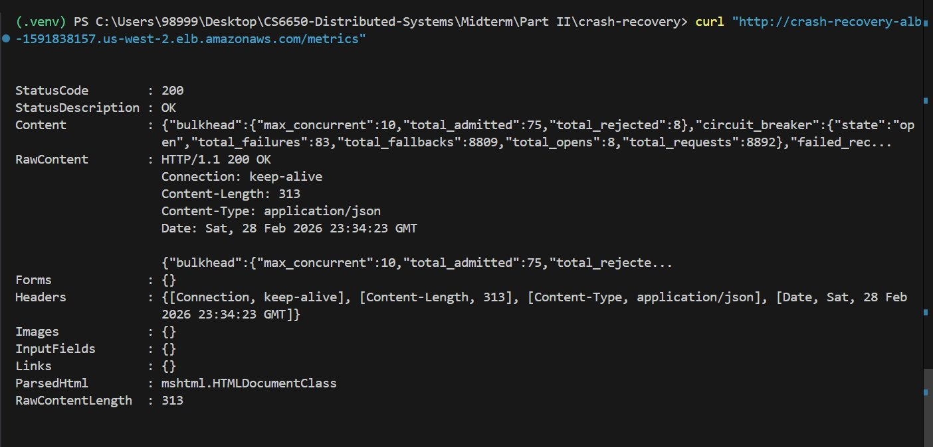
Figure 9: Resilience metrics in action. Circuit breaker: "open" (protecting the system). 8,809 fallback responses served. 83 timeout failures before breaker tripped. Bulkhead rejected 8 requests exceeding the 10-concurrent limit.

6. Phase 3: Automatic Recovery

6.1 Restoring the Downstream
The recommendation service was switched back to healthy mode:
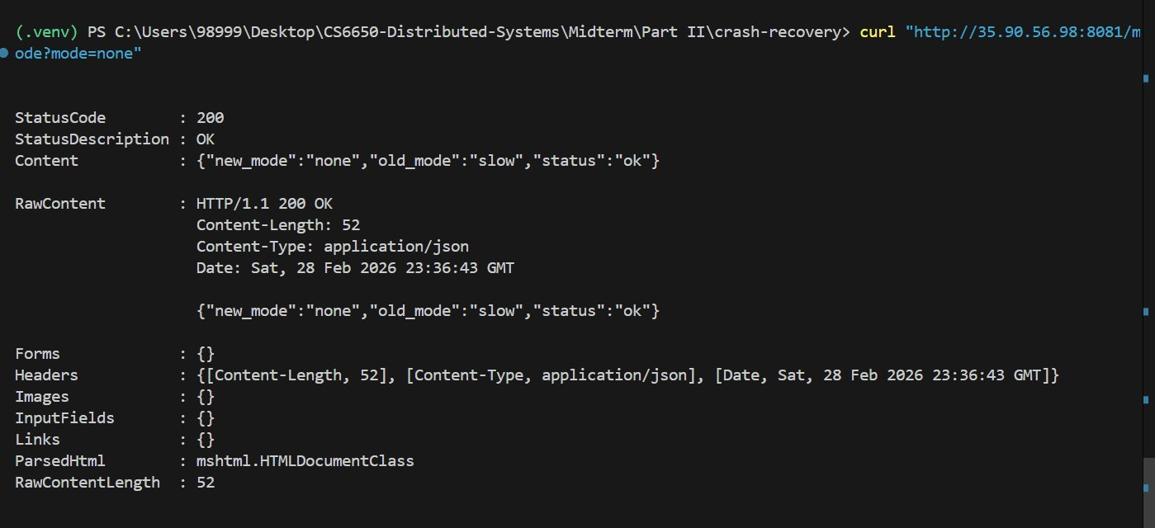
Figure 10: Switching the recommendation service back to normal (old_mode: "slow" → new_mode: "none").

6.2 Circuit Breaker Recovery
After restoring the downstream, a final 2-minute Locust test was run. The circuit breaker automatically recovered through its state machine: OPEN → HALF_OPEN (after 15-second timeout) → CLOSED (after 3 successful probe requests).
Metric | Baseline | Recovered | Difference
RPS | 89 | 89 | Identical
Avg Latency | 16 ms | 17 ms | +1 ms
Median | 15 ms | 17 ms | +2 ms
Max | 151 ms | 199 ms | Normal range
Requests | 6,854 | 10,648 | Fully recovered

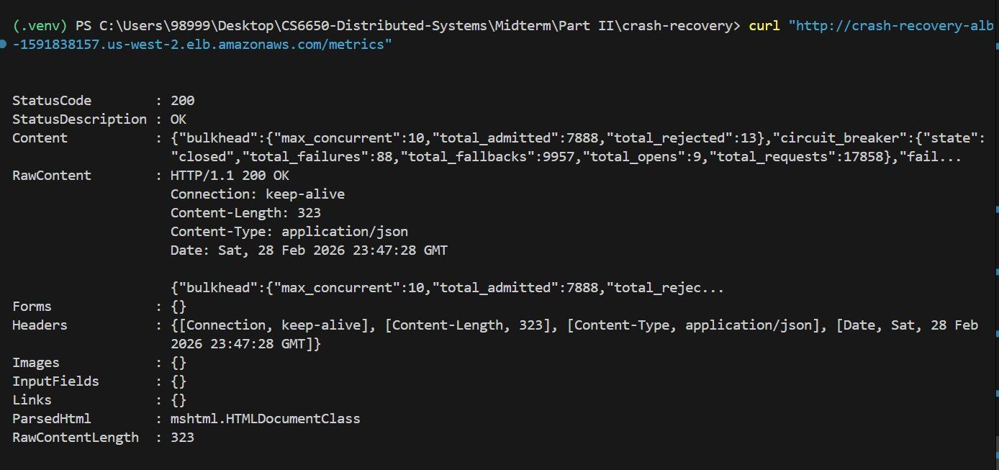
Figure 11: Final metrics showing circuit_breaker state: "closed". The system automatically detected recovery and resumed live downstream calls. 17,858 total requests processed across all test phases.

7. Key Takeaways
1. Cascading failures are silent killers.
The unprotected system didn't return errors — it returned successful responses, just 290x slower. From a monitoring perspective, error rates looked "fine" while throughput dropped 95%. Without resilience patterns, a single slow dependency can silently bring down an entire service.
2. CPU is not always the bottleneck.
CloudWatch showed CPU utilization below 8% during the cascading failure. The bottleneck was I/O wait — goroutines blocked on network calls. This is a common trap: teams scale up CPU or add instances when the real problem is unbounded downstream call duration.
3. Defense in depth works.
The three patterns complement each other: Fail Fast limits individual request damage (500ms cap), Circuit Breaker eliminates network overhead entirely after detecting failure (0ms for cached fallback), and Bulkhead prevents resource exhaustion even before the breaker trips (max 10 blocked goroutines). Together, they maintained 100% throughput recovery under identical failure conditions.
4. Graceful degradation beats hard failure.
With resilience enabled, users received fallback recommendations instead of errors or multi-second waits. The search functionality continued working perfectly — only the recommendation quality degraded temporarily. This is a key principle from Sam Newman: it's better to return slightly stale or generic data than to fail entirely.
5. Automatic recovery eliminates manual intervention.
The circuit breaker's state machine (CLOSED → OPEN → HALF_OPEN → CLOSED) meant the system recovered automatically once the downstream was restored. No restarts, no redeployments, no manual intervention — the service detected recovery and resumed normal operation within 15 seconds.

8. Tools and Technologies
Component | Technology
Search Service | Go (net/http, sync.Map, custom circuit breaker/bulkhead)
Recommendation Service | Go (net/http, runtime failure injection via /mode endpoint)
Containerization | Docker (multi-stage build, Alpine base image)
Infrastructure | Terraform (ECS Fargate, ALB, Target Group, Service Discovery, CloudWatch Logs)
Container Registry | Amazon ECR
Load Testing | Locust (HttpUser, 20 concurrent users, 4 test phases)
Monitoring | CloudWatch (CPU/Memory), custom /metrics endpoint (circuit breaker state, bulkhead stats)

